Digital Logic Design
(EL-1005)
LABORATORY MANUAL
Spring-2026

LAB 01
Introduction to DLD, Lab Tools & Basic Logic Gates

Vivek Kumar 25K-0925

NATIONAL UNIVERSITY OF COMPUTER AND EMERGING SCIENCES (NUCES), KARACHI
Lab Task:

Lab Task#1:
Implement the following logic circuit on logic trainer/logic work (attach screenshot below), and write truth table in the space provided below:
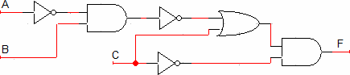
Figure 24: Combinational Circuit
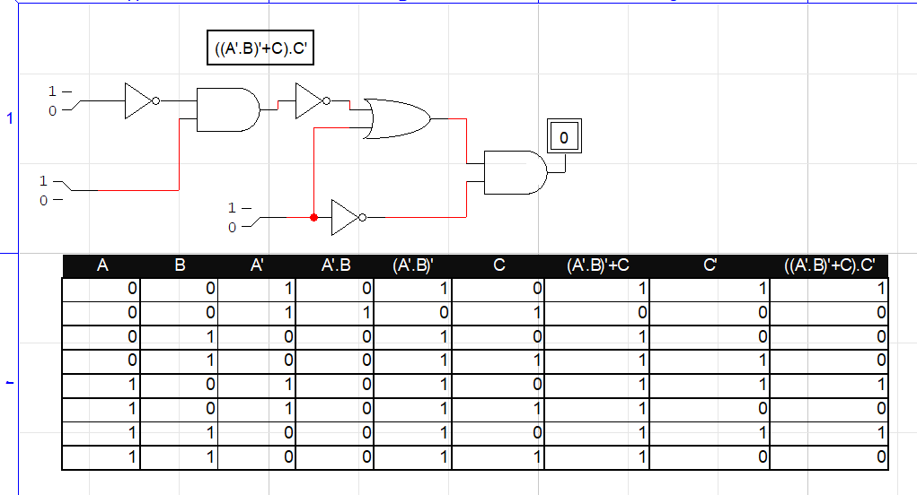

Lab Task#2
Draw the logic circuit represented by each of the following expressions (attach Screenshot):
- A+B+C+D
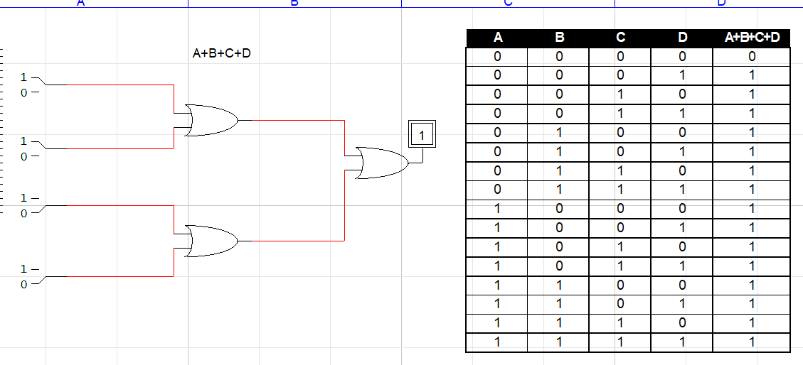
- ABCD
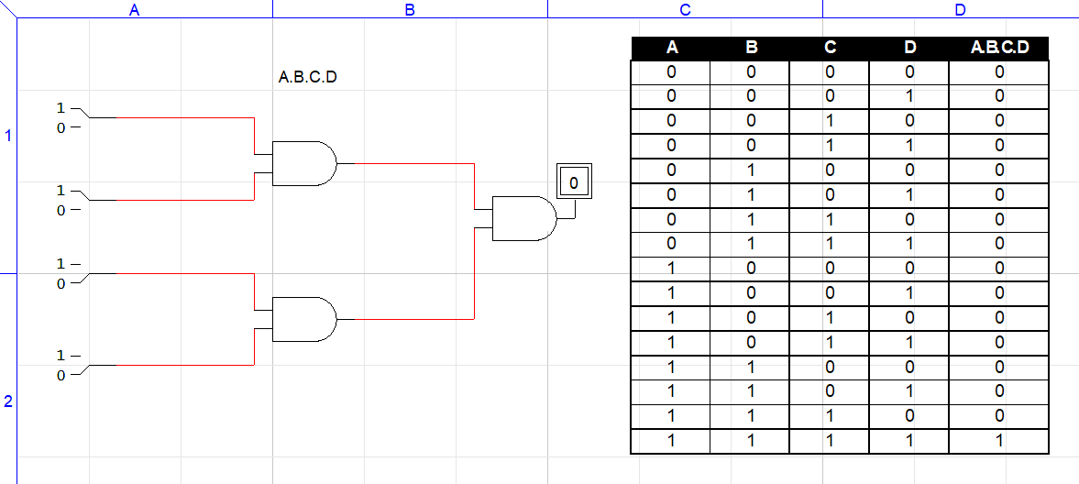

- A+BC
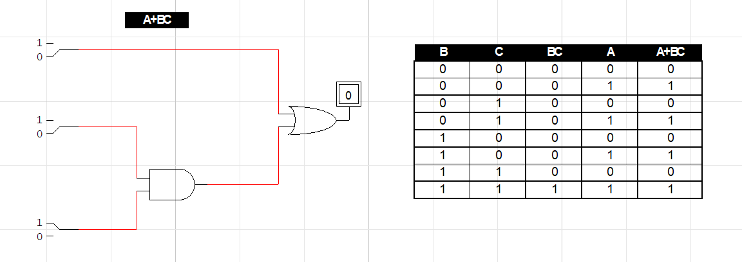
- ABC+D
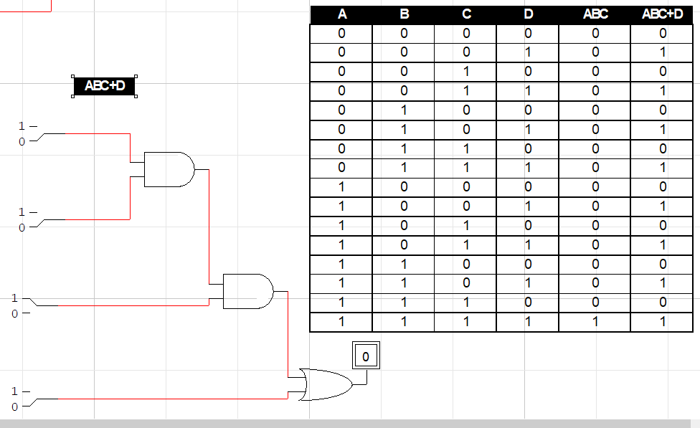
Lab Task#3:
Implement the following logic circuit on logic trainer / logic work, display circuit (or attach screenshot below) and write truth table in the space provided below:
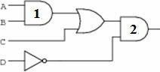
Figure 25: Combinational Circuit
